Student Name:
CWID:
Focus Area:
 | School of Global Studies and Partnerships  Master of Science in Global Studies  Oklahoma State University  i-study@okstate.edu  global.okstate.edu

Plan of Study Requirements
  Core Course Requirements: 15 hours
  Course # | Course Name | Hrs
  15 Required Hours:
  GS 5013 | Contemporary Issues/Intro to Graduate Studies | 3
  GS 5233 | Global Competitive Environment | 3
  GS 5313 | Global Communication and Public Diplomacy | 3
  GS 5413 | Overview of Global Development | 3
  GS 5513 | Global Crisis Management | 3
  3 Research Course Hours:
  GS 5133 | Research Design and Methods for Global Studies or other Research Course* | 3
  Focus Area Requirements: 15-18 hours
  Thesis Option
  Focus Area Hours | 9
  Thesis Hours | 6
  Creative Component Option
  Focus Area Hours | 12
  Creative Component Hours | 3
  Internship Opportunities
  Internship (GS 5110) - Can be counted as creative component or focus area course.
Program Requirements
Foreign Language Requirement
9 hours of second language or 3 hours of an advanced language OR obtain an intermediate level rating on the ACTLF Oral Proficiency Interview (actfl.org).
International Experience Requirement
Minimum of 3 weeks overseas in a structured course or internship as a graduate or undergraduate.
Research Design & Methods Requirement
*Recommended Research Courses:
REMS 5013 Research Design & Methodology SOC 5273 Qualitative Research Methods
MC 5113 Methods of Research in Mass Communication ENGL 4893 Research Writing for Int’l Graduate Students

Focus Areas
Global Business and Trade
This area focuses on global trade and economic development, with studies in trade policy, macroeconomic policy, political and legal structures surrounding global trade. This focus area is appropriate for students wishing to enter careers in international business, government, public service, institutional development, consulting, trade development, policy analysis and economic development.
Public Diplomacy and Global Communication
Global news organizations, emerging communication technologies, and the reconfiguration of social networks and ties have had a particularly potent impact on how we communicate internationally, so much so that governments are building capacity in public diplomacy in order to better manage the impact of media on international relations. This focus area is designed to help students develop skills and theory in public diplomacy so that they are better prepared for careers in government service, business, or other fields that require an understanding of the global communication environment.
Global Leadership and Development
This focus area addresses fundamental global challenges, and developing the skills that will enable students to be leaders in addressing humanitarian and social issues in diverse cultural settings. Depending on their interests, students may select courses that address: human rights, nutritional problems, health care human capital development, educational needs and occupational training. Students completing this area prepare for careers in international service agencies, humanitarian groups, educational and research institutions and consulting firms.
Global Disaster and Crisis Management
The Global Disaster and Crisis management focus area emphasizes global development through crisis management, such as natural disasters, political crisis, or social conflict. This track prepares students in government or non-profit organizations.

The MSGS program requires students to take 9-12 hours from a focus area. Choose 3-4 courses from one of the focus areas listed below.
Global Business and Trade  GS 5333 Certified Global Business Professional  GS 5070 Global Trade Economics  GS 5020 Trade and Investment Promotion Strategies  MKTG 5553 International Marketing Strategy  AGEC 5343 International Agricultural Markets and Trade  MGMT 5743 International Negotiations  ECON 5603 Global Economics  DHM 5663 International Merchandising Management  FIN 5213 International Finance  BAN 5733 Business Analytics  MSIS 5313 Production Management  EEE 5403 Social Entrepreneurship  GS 5020 Independent Study in Global Studies  GS 5070 Special Topics in Global Studies  Other courses as approved by Director of MSGS program | Public Diplomacy and Global Communication  MC 5253 International Mass Communication  GS 5323 Nation Branding  GS 5343 The Geopolitics of New Media  GS 5043 Politics in a Global Economy (cross list with POLS 5043)  GS 5223 Culture, History and World Systems (Same as SOC 5223)  SOC 5333 Global Population and Social Problems  HIST 6130 Graduate Studies in History (Public Diplomacy)  POLS 5673 Understanding and Responding to Terrorism  POLS 5203 ProSeminar in International Relations  POLS 5403 ProSeminar in Comparative Politics  AGCM 5503 Risk and Crisis Communication in Agricultural Sciences and Natural Resources  GS 5020 Independent Study in Global Studies  GS 5070 Special Topics in Global Studies  Other courses as approved by Director of MSGS program | Global Leadership and Development  GS 5223 Culture, History and World Systems (Same as SOC 5223)  AGED 5703 Cultural Competency for Working in Agricultural and Extension Education  ANTH 5243 Globalization and Culture  GEOG 5233 Human Dimensions of Global Environmental Change  HRAE 5833 Global Consulting  HCA 5153 International Health Systems  MGMT 5093 Management of Non-Profit Organizations  NSCI 5553 Global Nutrition and Food Security  WAED 5133 Internationalism, Globalization and Occupational Education  POLS 6303 Populations at Risk  SCFD 6023 Comparative Education  EEE 5403 Social Entrepreneurship  AGIN 5312 Applied Issues in International Agriculture  GS 5020 Independent Study in Global Studies  GS 5070 Special Topics in Global Studies  Other courses as approved by Director of MSGS program | Global Disaster and Crisis Management  GS 5070 Transnational Criminal Networks  GS 5020 Global Poverty and Inequality  GS 5533 Complex Emergencies  GS 5543 Dimensions of Fire and Emergency Management  POLS 5673 Understanding and Responding to Terrorism  POLS 6203 Comparative and International Dimensions of Fire and Emergency Management  POLS 6303 Populations at Risk  POLS 5933 Disaster Response  POLS 5923 Preparedness and Planning  POLS 6300 Special Topics in Fire and Emergency Management  AGCM 5503 Disaster Management & Communication in Agriculture & Natural Resources  SOC 6493 Sociology of Disaster  NSCI 5553 Global Nutrition and Food Security  GEOG 5233 Human Dimensions of Global Environmental Change  GS 5020 Independent Study in Global Studies  GS 5070 Special Topics in Global Studies  Other courses as approved by Director of MSGS program
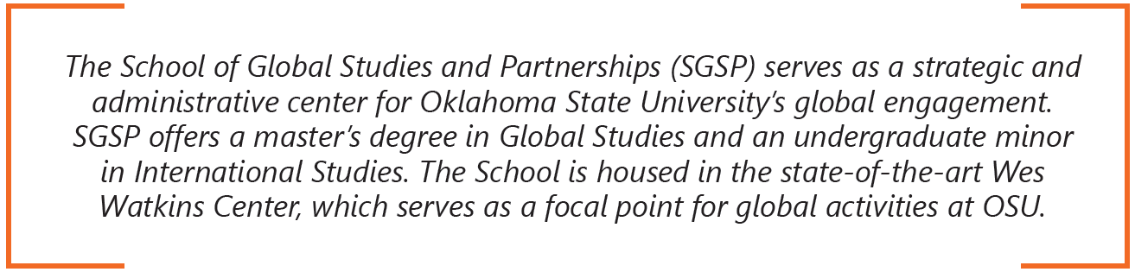

OSU course descriptions can be found at registrar.okstate.edu/Course-Descriptions



